APPLICATION DEADLINE: APRIL 2, 2024
Fair & Affordable Rental Housing
Pleasantville Lofts
Village of Pleasantville, Westchester County, New York 10570
Studio, One and Two Bedroom Apartments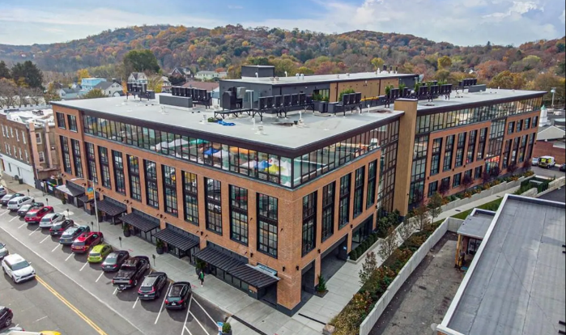
Building & Community Features
Pleasantville Lofts at 70 Memorial Plaza is a mixed-use, mixed-income newly constructed development in downtown with street level retail and 79 apartments, including 71 market rate and 8 affordable. Building amenities include work space rooms, library lounge, fire-pit, pickle ball court, self-storage, roof top deck with outdoor kitchen, lounge and dining space. Served by the Pleasantville Union Free School District. Metro North’s Pleasantville Station (Harlem Line) is within walking distance providing transportation to and from New York City and points North.

# of Apartments | Rents | Maximum Household Income
1 Studio | $1,888 | 1 person - $82,250
5 One Bedrooms | $2,008 | 1 person - $82,250 | 2 person - $94,000  3 person - $105,750
2 Two Bedrooms | $2,386 | 2 person - $94,000 |3 person - $105,750 4 person - $117,450
* Maximum Household Income as of April 2023, subject to change. Utilities Not Included in Rent
Rents subject to change

FOR ADDITIONAL INFORMATION, CALL HOUSING ACTION COUNCIL
(914) 332-4144 or email hac@affordablehomes.org
APPLY ONLINE: www.housingactioncouncil.org

